1. Reading array data from the document
2. To read the below array data
3. 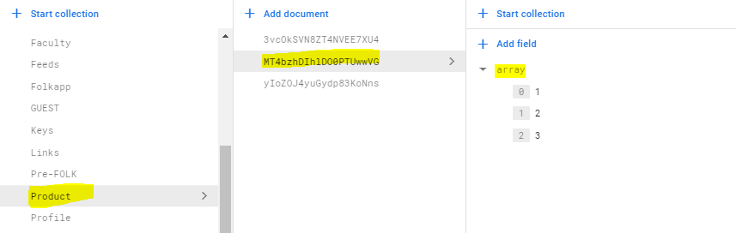
4. Code:
5. docs = db.collection(u’Product’).document(‘MT4bzhDIhlDO0PTUwwVG’)

docs = docs.get()

docs = docs.to_dict()

print(docs[‘array’])